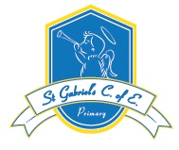
Week Beginning: 6.7.20
Year  Reception  Hello children. In Week 5/Summer 2, we continue with our Whatever the Weather topic. We hope you are enjoying your online work. Take care and keep safe. Hopefully we will see you soon. | English  Write four super sentences about the weather. Remember capital letters, finger spaces and full stops.  We have now subscribed to Oxford owls while it is free. You can read e-books linked to our guided reads. Go to Oxford Owls and my class login: stgabrielsreception  Password: mrsdoyle  Spiders/Ladybirds – What’s In The Woods e-book  Dragonflies/Butterflies – A Bad Mood e-book  Bees – Paco’s Pet e-book  Caterpillars- Cats e-book | Maths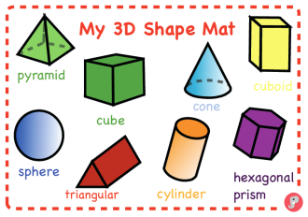  Learn these 3-d shapes. Where can you see shapes like them around your house? For instance, a tissue box is like a cuboid. | Topic  Write two lists of food that grows in countries that have cold or hot weather.  Use BBC bitesize to help  https://www.bbc.co.uk/bitesize/topics/z849q6f/articles/z7dkhbk
SPAG/Phonics  Letters and Sounds Week 9  from the Department for Education website. | R.E  Design and make a rainmaker. 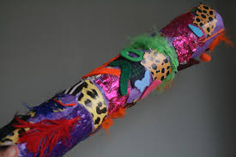  Use a cylinder/crisps container made of cardboard. Put two handfuls of rice inside and make sure the lids are stuck on with glue. Decorate the outside of the box. Now have a go at making music. Perhaps sing a song you have made up thanking God for the rain and the sunshine. | Tricky Words  Practice writing  He  She | Useful Links:  www.twinkl.co.uk/offer  www.topmarks.co.uk

