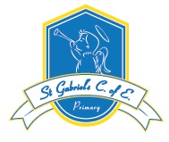
Week Beginning: 6th July 2020

Year 4 Hello Children and Parents.  Here are the tasks for this week.  Please ensure you are accessing TTRS. If you have forgotten your password, please contact school and I can send it to you.  I hope you are getting some daily exercise-try BBC super movers.  Send photos to Mrs Brown of work you have done or how you are keeping busy. Remember to state that you are happy for the photos to go on the school facebook/website pages.  Lets hope we get some lovely weather again soon.  We miss you all and hope to see you soon.  Miss Cotogni & Mrs Dunning.  #stay alert! | English-retrieving and recording information.  Read the text below and then answer the questions. Use the text to help you find and write the answers.  See below. | Maths-Measurement- Timetables  Everyone needs some structure in their life. A timetable is really useful for this. Look at the attached sheet and answer all the questions. | Topic- Shaping up!  This summer should have been packed with sporting evets.  - The 2020 UEFA European Football Championship.  - The 2020 Summer Olympics  - Wimbledon  Chose a sport from one of the above and research it.  Number of participants, training required etc.  Create a fact file about it.
SPaG: Practise your punctuation.  Punctuate these sentences.  mr barnes filled the watering can  joe abdul mark and spohie arrived on friday  when did you sell that lovely picture  mrs simons lost her purse in the grass  the children whispered to each other  the soldiers captured some spies | R.E  Write your own prayer about things that you are grateful for. | Spellzoo Group 1: *  Early, earth, eight, eight, enough, exercise, experience, extreme, famous, favourite.  Group 2:*  Child, children, Christmas, class, climb, clothes, could, cold, door, even. *Remember to write a sentence for each of the words. | Useful Links: https://www.topmarks.co.uk/  https://www.bbc.co.uk/bitesize/levels/zbr9wmn  https://ttrockstars.com/  Youth Sports Trust are recommending these YouTube videos for keeping fit at home Lbrown@stgabrielsce.rochdale.sch.uk  Remember to visit this website for more SPaG activities https://www.topmarks.co.uk/english-games/7-11-years/spelling-and-grammar

Maths continued
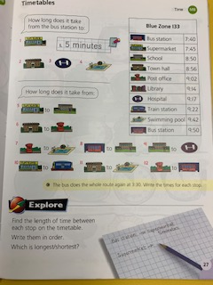
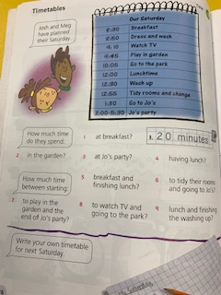

What is the sun?
The sun is a star. It is the nearest star to Earth, which is why it seems much bigger than any other star, but really the Sun is quite a small star.
Some stars, that are much further away, are thousands of times bigger than the Sun.

The Sun is a huge ball of fiery gas. It is 150 million kilometres from Earth, and without it, there would be no light or warmth on Earth. If the sun did not give us light and heat there would be no life on Earth, so the Sun is very important to us. We are not its only planet though, it has eight others.
It takes Earth about 365 days or one year, to travel once round the sun.

Copy these sentences.

Choose the correct ending to finish each sentence.
- Most stars are _______________. (smaller than the Sun, the same size as the sun, bigger than the Sun)
- The Sun is made of ________. (glowing rocks, red water, fiery gases)
- The distance from Earth to the Sun is ___________. (15 million kilometres, 150 million kilometres, 1500 million kilometres)
- Once every year __________ . (the Sun travels around the Earth, the Moon travels around the Earth, the Earth travels around the Sun)

 | A | B | C
1 | 150 | Light | 8
2 | Heat | 365 | The Sun
3 | 1 | Gas | thousands

Use the grid to answer the questions with grid references.
- How many planets, apart from Earth, does the Sun have? (C1)
- How many times bigger than the Sun are some other stars?
- What two important things does the Sun give to the Earth?
- How many days does the Earth take to circle the Sun?
- How many years does the Earth take to circle the Sun?
- Which is the nearest star to the Sun?
- What is the Sun made of?

